DOUGLAS A. DUCEY
Governor
THOMAS BUSCHATZKE
Director
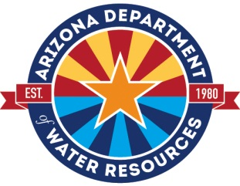

ARIZONA DEPARTMENT of WATER RESOURCES
1110 West Washington Street, Suite 310
Phoenix, Arizona 85007
602.771.8500
azwater.gov

ADWR Supply & Demand Assessment
Public Meeting

December 8, 2022, 2:00 p.m. – 3:30 p.m. | Webinar & In-person

Location: Arizona Department of Water Resources
1110 W. Washington Street, 3rd Floor, Suite 310
Phoenix, Arizona 85007

Webinar Link: Join the meeting by clicking https://azwater.webex.com/wbxmjs/joinservice/sites/azwater/meeting/download/b8e3f143e6834a1c85a4061aaff9237f?siteurl=azwater&MTID=m629eaa0a192e8fa71bd8471d13446f4e |

MEETING NUMBER: 2597 985 0568 PASSWORD: SupplyandDemand

Phone Only Access: +1-415-655-0001 US Toll Free| Access Code/ID: 2597 985 0568
– Agenda –
- Welcome & Overview
- 2023 Groundwater Basins
- Data & Methods
- Question & Answer

This meeting is open to the general public. A copy of this meeting notice is posted at the Arizona Department of Water Resources, First Floor Public Notices Bulletin Board, 1110 W. Washington Street, Phoenix, Arizona 85007.

People with disabilities may request reasonable accommodations such as interpreters, alternate formats, or assistance with physical accessibility. If you require accommodation or have any questions, please contact Theresa Johnson at tjohnson@azwater.gov or 602-771-3974. Please make requests as soon as possible to allow time to arrange the accommodation.

